# SoE 2021 Marine Expert Assessments

STATE AND TREND ASSESSMENT: Water column (epipelagic)

Richardson AJ1,2, Everett JD1,2,3, Davies CH4

1 Centre for Applications in Natural Resource Mathematics, School of Mathematics and Physics, The University of Queensland, St Lucia, QLD, 4072, Australia

2CSIRO Oceans and Atmosphere, Queensland Biosciences Precinct, St Lucia, QLD, 4067, Australia

3 School of Biological, Earth and Environmental Science, University of NSW, Sydney, NSW, 2052, Australia.

4CSIRO Oceans and Atmosphere, GPO Box 1538, Hobart, TAS, 7001, Australia

*Assessment reviewers:*

Kerrie Swadling (UTas) – [K.Swadling@utas.edu.au](mailto:K.Swadling@utas.edu.au)

**Description of species/habitat/community/process (incl. spatial area of relevance)**

The water column (pelagic) community includes microbes, phytoplankton, zooplankton, fish and other higher trophic levels including seabirds, marine reptiles and marine mammals. By definition, the pelagic community is mobile, as smaller species are moved passively by currents, and larger species often move over large distances, both horizontally and vertically. Here we focus on the epipelagic zone, which we have defined as the top 200 m of the water column off the continental shelf (i.e., in waters >200 m depth).   
Across Australia’s management bioregions, we analysed the abundance/biomass of a selected group of pelagic trophic levels: Chlorophyll *a* (representing phytoplankton biomass) from satellite; and Zooplankton biomass from the IMOS Australian Continuous Plankton Recorder (AusCPR) survey.

**Pressures/issues of importance**

Across the epipelagic zone, climate change and fishing are likely to be the major pressures (Richardson & Schoeman 2004, Burgess et al. 2018). Fishing negatively impacts the biomass of many fish species directly though targeted catch, and seabirds, sea turtles, marine mammals and fish as bycatch (Burgess et al. 2018). Fishing can also lead to top-down cascades (Cury et al. 2000), but this might be rare over large regions, where climate is likely to be more important (Richardson & Schoeman 2004).

**Current state and recent trend (2016-2021) of species/ habitat/ community/ process (refer to the key to grades for state, trend provided for consistency of language)**

Based on the components of the epipelagic community we examined, there is evidence for increases in biomass in some bioregions, but no change in others (Fig. 1). For Chlorophyll *a* from satellite, two of the six Australian bioregions show significant increases (the South-east and South-west), and the remainder show no change. For Zooplankton biomass from AusCPR, there are data for only four bioregions, with three showing significant increases (South-east, South-west and Coral Sea) and the other showing a significant decline (Temperate east). In summary, there is consistent evidence that both Chlorophyll *a* (an index for phytoplankton biomass) and Zooplankton biomass are increasing in the South-east and South-west bioregions, but the results for other bioregions are less consistent.

**Resilience**

The base of the epipelagic community, i.e. plankton, is more resilient to human pressures than higher trophic levels such as fish, although we did not analyse data on the latter.

**Main uncertainties and knowledge gaps associated with providing an assessment of current state and recent trend**

Chlorophyll *a* from satellite and Zooplankton biomass from IMOS AusCPR data have both been collected consistently throughout their time series. Chlorophyll *a* is excellent for providing a large-scale view, as we are doing here, of phytoplankton biomass, but it is only a proxy, and the exact biomass varies depending on the precise phytoplankton community present, amongst other things. Unfortunately, it was beyond our time constraints to summarise all available information on fish catch (which is a relatively poor abundance of biomass because of management and selectivity biases), seabirds, sea turtles and whales. There are also limited fishery-independent estimates of fish biomass in Australian waters. We have thus analysed only select components of the epipelagic community.

**Pressures/issues of importance and associated management**

There is scope for management interventions in some areas and some components of the epipelagic community. For example, for higher trophic levels, management interventions can ensure sustainable fisheries management practices. And for semi-enclosed coastal areas, eutrophication can be managed to reduce impacts on phytoplankton (here we used Chlorophyll *a* as a proxy) and zooplankton. However, probably the main driver of large-scale changes in the epipelagic community as a whole is climate change.

**Outlook**

Continued monitoring of the epipelagic water column community will enable the future identification of both abrupt and long-term changes. Once IMOS time series are >20 years long, we will be more confident in distinguishing long-term trends from short-term variability in the pelagic community (Poloczanska et al. 2013, Hoegh-Guldberg et al. 2014).

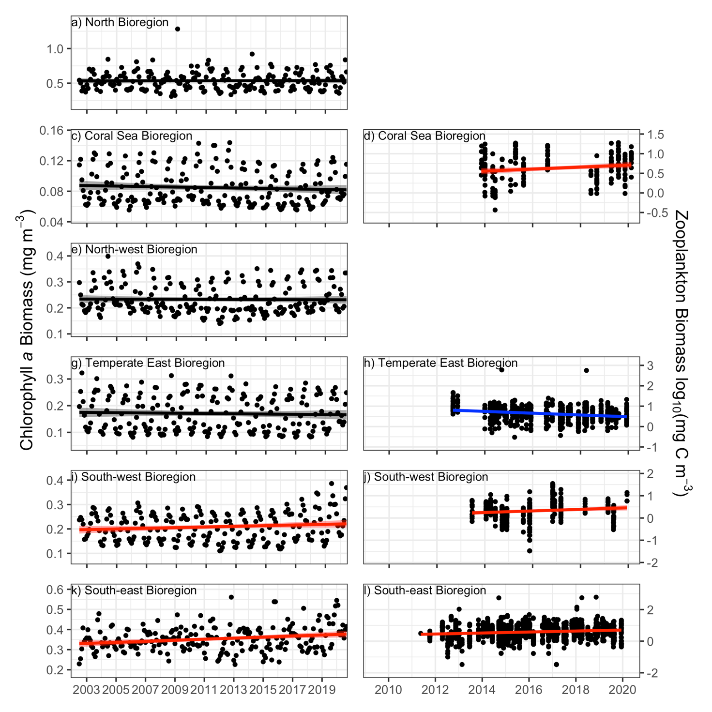

**Figure 1.** Data from IMOS showing: (left) concentration of Chlorophyll *a*; and (right) Zooplankton biomass. Black dots represent data points and the line (and shading) represent the linear regression (and confidence intervals) of the data after the seasonal cycle has been removed. Colours show the direction and significance of the trend: Blue: significantly decreasing, Red: significantly increasing, Black: no significant trend.*Assessment summary*

|  |  |  |  |  |  |
| --- | --- | --- | --- | --- | --- |
| Year | Assessment grade | | Confidence | | Comparability with 2016 assessment |
| Grade | Trend | Grade | Trend |
| 2021 | Good | Stable | Very limited (mainly because higher trophic levels not assessed) | Very limited (mainly because higher trophic levels not assessed) | NA |
| 2016 | NA | NA | NA | NA | NA |

**Summary text:** We analysed a limited representation (phytoplankton and zooplankton) of the epipelagic community based on IMOS data. There was no consistent trend among locations and trophic levels.

**State and trend of bioregion relative to the national assessment:**

Note we have provided assessments for Chlorophyll *a* and Zooplankton biomass, but have no data for higher trophic levels in the epipelagic community.

*North:* Good (no change) in Chlorophyll *a* (Confidence = Adequate)

*North-east (Coral Sea):* Good (no change) in Chlorophyll *a* (Confidence = Adequate) and Improving (increasing) for Zooplankton biomass (Confidence = Limited)

*Temperate-east:* Good (no change) in Chlorophyll *a* (Confidence = Adequate) and Declining (decreasing) for Zooplankton biomass (Confidence = Limited)

*South-east:* Improving (increasing) for Chlorophyll *a* (Confidence = Adequate) and Zooplankton biomass (Confidence = Limited)

*South-west:* Improving (increasing) for Chlorophyll *a* (Confidence = Adequate) and Zooplankton biomass (Confidence = Limited)

*North-west:* Good (no change) in Chlorophyll *a* (Confidence = Adequate)

**References**

Burgess, M.G., McDermott, G.R., Owashi, B., Reeves, L.E.P., Clavelle, T., Ovando, D., Wallace, B.P., Lewison, R.L., Gaines, S.D., Costello, C., 2018. Protecting marine mammals, turtles, and birds by rebuilding global fisheries. Science 359, 1255–1258.

Cury, P., Bakun, A., Crawford, R.J.M., Jarre, A., Quiñones, R.A., Shannon, L.J., Verheye, H.M., 2000. Small pelagics in upwelling systems: patterns of interaction and structural changes in “wasp-waist” ecosystems. *ICES J Mar Sci* 57, 603–618.

Hoegh-Guldberg O, Cai R, Poloczanska ES, Brewer PG, Sundby S, Hilmi K, Fabry VJ, Jung S, and 21 Contributing authors including Richardson AJ (2014) Chapter 30: The Ocean. In: *Climate Change 2014: Impacts, Adaptation, and Vulnerability. Part B: Regional Aspects.* *Contribution of Working Group II to the Fifth Assessment Report of the Intergovernmental Panel on Climate Change* [Barros VR, Field CB, Dokken DJ, Mastrandrea MD, Mach KJ, Bilir TE, Chatterjee M, Ebi KL, Estrada YO, Genova RC, Girma B, Kissel ES, Levy AN, MacCracken S, Mastrandrea PR, White LL (Eds)]. Cambridge University Press, Cambridge, United Kingdom and New York, NY, USA, pp. 1655-1731.

Poloczanska ES, Brown CJ, Sydeman WJ, Kiessling W, Moore PJ, Brander K, Bruno JF, Buckley L, Burrows MT, Duarte CM, Halpern BS, Holding J, Kappel CV, O’Connor MI, Pandolfi JM, Parmesan C, Schoeman DS, Schwing F, Thompson SA, Richardson AJ (2013) Global imprint of climate change on marine life. *Nature Climate Change* 3: 919-925. *DOI 10.1038/NCLIMATE1958.* 7 pp.

Richardson AJ, Schoeman DS (2004) Climate impact on plankton ecosystems in the Northeast Atlantic. *Science* 305: 1609-1612.

Richardson, A.J., Walne, A.W., John, A.W.G., Jonas, T.D., Lindley, J.A., Sims, D.W., Stevens, D., Witt, M., 2006. Using continuous plankton recorder data. Progress in Oceanography 68, 27–74.

*Metadata*

Please include details of:

1. Data used in the assessment (incl. spatial and temporal coverage)

As our index of phytoplankton biomass, we analysed Chlorophyll *a* data from the IMOS Satellite Remote Sensing facility. For Zooplankton, we used biomass data from IMOS AusCPR survey. AusCPR data are collected on 5 nautical mile samples and the zooplankton on every 4th sample along a route is washed onto a filter paper, dried and weighed.

1. Quality of data used in the assessment

The Chlorophyll *a* data from the IMOS Satellite Remote Sensing facility has been validated against other ocean colour production. For Zooplankton biomass, IMOS data are the only time series information available in Australia. Before the introduction of the IMOS AusCPR survey, assessment of zooplankton biomass was not possible in the epipelagic zone. Collecting and counting IMOS AusCPR data adheres to strict quality control protocols (Richardson et al. 2006).

1. Custodian and location of data

Chlorophyll *a* data were processed by the IMOS Satellite Remote Sensing facility. Zooplankton biomass data were processed by the IMOS AusCPR facility. All data are freely available from the AODN (<https://portal.aodn.org.au/>).

1. Method used to determine state or recent trend

For Chlorophyll *a* and Zooplankton biomass, data were used as response variables in linear models, with Year and Month (to adjust for seasonality and reduce temporal autocorrelation) as predictors. The trend line in each figure is the slope of the Year term. Following visual assessment of the diagnostic plots of the model, we log10-transformed Zooplankton biomass to reduce leverage of outliers and to improve the homogeneity of variance assumption. No transformation was needed for Chlorophyll a data to meet the underlying assumptions for the linear model.

1. If the assessment has changed from the 2016 assessment what factors/parameters have contributed to the change and how?

NA

Relevant publications (particularly those published since the 2016 assessment) and links to publications

**Support for zooplankton state and trends observed**

Richardson AJ, Eriksen R, Moltmann T, Hodgson-Johnston I, Wallis JR (2020) State and Trends of Australia’s Ocean Report, Integrated Marine Observing System, Hobart. 164 pp. A total of 27 contributions from 70 authors from 12 institutions. <https://www.imosoceanreport.org.au/>